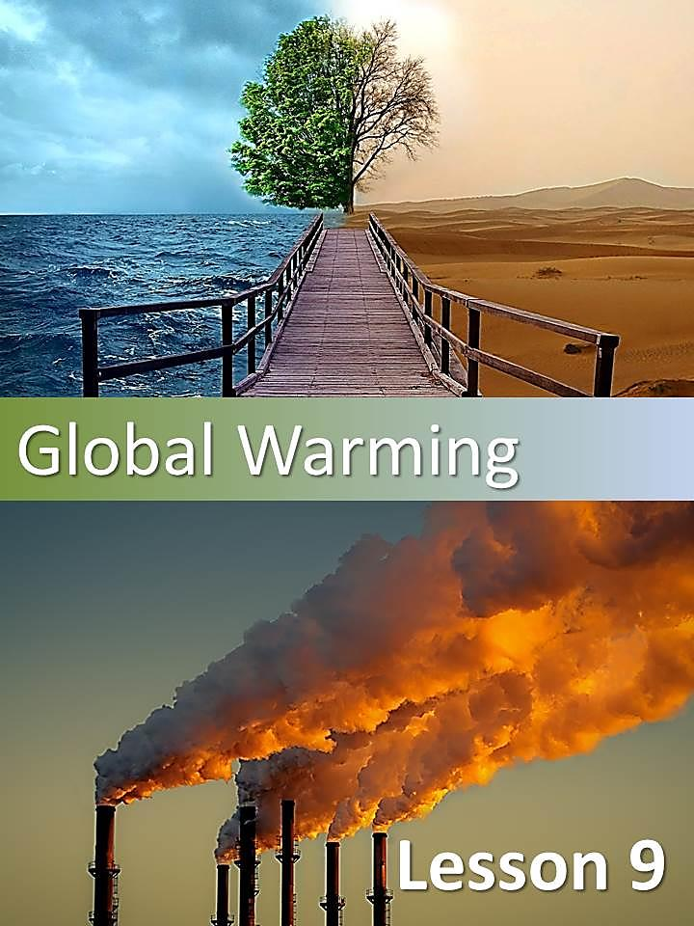

*  Have a look at the picture below. What do you think the text is about? Try to explain the picture.

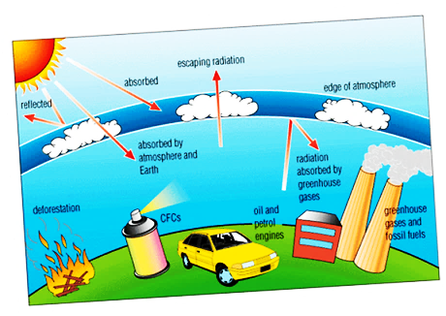

*  Read the following article carefully and state the main idea of each paragraph.

| Ozone layer | **MAIN IDEA** |
| --- | --- |
| Most of us have seen products that claim to be “ozone friendly” or CFC free”, but not many people actually know what exactly is happening to the ozone layer.  The ozone layer is part of the earth´s atmosphere (about 40km thick) that protects the earth from the sun´s ultraviolet rays. If the ozone layer did not exist, no life could survive on the planet. About 30 years ago, scientists discovered that human actions had a negative effect on the global ozone layer. Research has shown that certain chemicals called CFCs (chlorofluorcarbons) cause direct damage to the ozone layer. Industries have used these chemicals in different ways such as refrigeration, air conditioning, cleaning materials and aerosol sprays for a long time. If they had known that these chemicals were so harmful to the earth, they would have replaced them with non-toxic equivalents. |  |
| At first scientist thought that the ozone layer was slowly thinning all over the world. However, in 1985, they discovered that there is a large hole in the ozone that is growing above the Antarctica. Each year, the ozone over this part of the earth has been reduced by over 50 percent. A thinner ozone layer means that life on earth is exposed to too much ultraviolet radiation. This can cause skin cancer, make the immune system less effective and interfere with plants´ability to get energy (photosynthesis). It also threatens the growth of ocean plants. Because of these dangers, many countries have tried to eliminate the manufacture and use of CFCs. However, CFCs can stay in the atmosphere for more than 100 years.  The destruction of the ozone layer is something that will continue to be a threat for years to come. |  |

*  What does the text say about the following concepts?

|  |  |
| --- | --- |
| **OZONE LAYER** |  |
| **CFCs** |  |
| **INDUSTRIES** |  |
| **ULTRAVIOLET RAYS** |  |
| **ANTARTICA** |  |
| **DANGERS** |  |

* Go back to the text…

1. What does the label “ozone friendly” mean?

1. that the product is made of ozone.
2. it will not damage the ozone.
3. that it is harmful to the ozone.

2. In paragraph 2, find a verb that means ***obtener***.Use thedictionary and find out other meanings of this verb?

3. In paragraph 2, find a noun that means ***amenaza***.

4. What does the expression **such as** in the text introduce?

1. an example
2. a condition
3. an alternative

5. Give the meaning of the word **actually** (paragraph 2). Is it a cognate or a false cognate?

6. The word**ultraviolet** appears in the text above. Can you identify the suffix? What effect does it have on the meaning of the word? Can you think of other examples?

* What do you think?

### Global warming

The planet is in our hands. What do you think we can do to protect it? List and give reasons for 5 golden rules to keep our planet clean, safe and green.

1.

2.

3.

4.

5.

* Read the following text.

If you have ever tried to grow plants, you know that most plants need a warm environment. For this reason plants are grown in greenhouses built from glass. The glass traps the warm air inside so that the plants can grow.

This happens on the Earth as well. Gases found naturally in the atmosphere trap the heat of the sun and warm up the earth to a comfortable 59° degrees Fahrenheit (15° Celsius). This is called the “greenhouse effect”. The greenhouse effect makes it possible for humans, animals and plants to live. If these gases were not in the atmosphere, the earth would be a frozen snowball.

Human activities have caused some greenhouse gases, such as carbon dioxide, to build up in the atmosphere. Whenever we burn fossil fuels such as gasoline, oil, coal or natural gas, more greenhouse gases are being released into the atmosphere. As a result, the atmosphere is trapping more heat and the earth is warming up. This phenomenon is known as global warming.

Scientists do not agree about the possible effects of global warming. Some claim that there is no reason to be alarmed. They claim that global warming will take generations to affect the earth. Others predict that if we do not reduce the release of greenhouse gases, global temperatures could rise several degrees within the next 100 years. This change in temperature could mean major climate changes throughout the world.

Scientists claim that global warming is not like turning on a heater, we cannot just turn it off if the earth warms up too much. Once greenhouse gases are released into the atmosphere, most of them remain there for decades and continue to trap heat.

For this reason, many environmentalists say that we need to act now and prevent any future damage. Today, environmental groups are educating people to limit the activities that contribute to global warming.

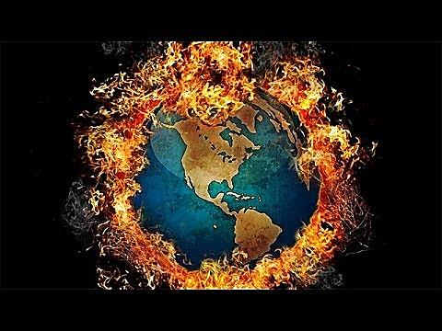

* Read the questions and tick the correct option.

1. Which of the following words from the context help us understand the meaning of “trap”?

|  |  |  |  |
| --- | --- | --- | --- |
| Warm □ | Inside □ | Plants □ | Grow □ |

1. Which of the following are examples of fossil fuels?

|  |  |  |
| --- | --- | --- |
| Carbon dioxide □ | Coal □ | Gasoline □ |
| Oil □ | Heat □ | Natural gas □ |

* Go back to the text and complete the following chart about the causes and effects of global warming.

|  |  |
| --- | --- |
| **Causes** | **Effects** |
|  |  |
|  |  |
|  |  |
|  |  |

* In the last paragraph the author refers to activities that people should limit to contribute to the reduction of global warming. Which activities do you think he refers to and why?
* Read the following article carefully.

### An effect of global warming.

One **effect** of **global** warming could be draught. In some arid places, it **does** not rain much and plant life depends mainly **on** water from lakes and rivers. When the temperatures **rise**, water evaporates **faster**. If the temperature were to rise, the water in these areas would evaporate and cause a **water shortage**. Crops would **definitely** die and many unfortunate people **and** animals would be hungry and thirsty.

A drought **could** also increase **the** rate of global warming. If there were **fewer** plants to take carbon dioxide out of the air, the atmosphere would continue to heat up and cause other drastic changes throughout the world.

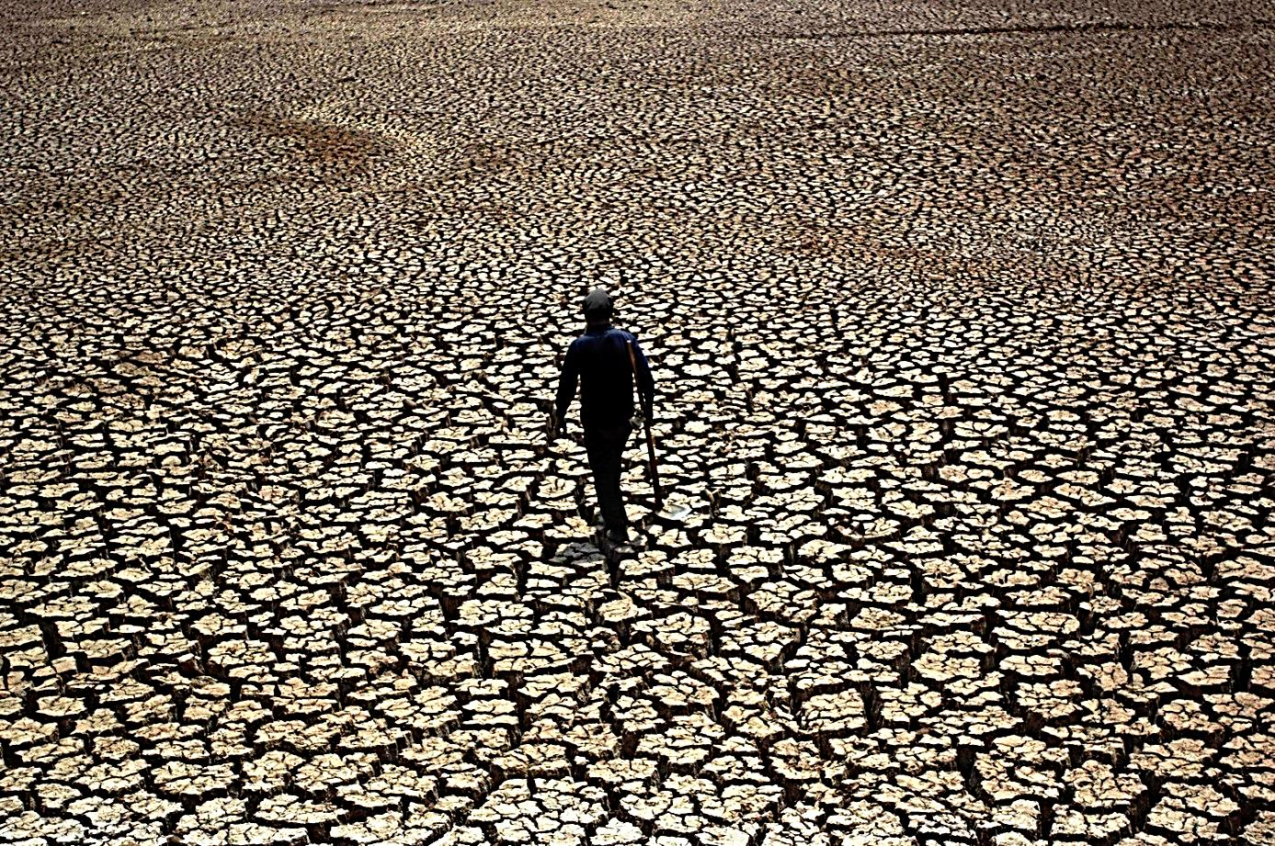

* Choose the correct option.

**What is a drought?**

1. Desert winds.
2. Very hot weather.
3. Increased global warming.
4. A water shortage.

* Let’s review some expressions from the text. Match the words and provide a suitable translation for each expression.

|  |  |  |
| --- | --- | --- |
| Human | heat |  |
| Global | changes |  |
| Greenhouse | rise |  |
| Climate | warming |  |
| Water | shortage |  |
| Environmental | gases |  |
| Temperature | gropus |  |
| Trap | activities | = acción, actividad del hombre |

#### http://www.literautas.com/es/blog/wp-content/uploads/eye-magnifying-glass-book.gifRevision

* Read the text again and state the type of word that is in bold.

| **Example from the text** | **Type of word** |
| --- | --- |
| effect |  |
| global |  |
| does |  |
| on |  |
| faster |  |
| water shortage |  |
| definitely |  |
| could |  |
| and |  |
| fewer |  |
| the |  |
| rise |  |

#### MC900404011[1]CONDITIONAL SENTENCES

En el nivel 1 hemos visto los condicionales de tipo 0 y 1. Hagamos un breve repaso:

El uso del condicional significa que una acción depende de otra. Las **oraciones condicionales** se utilizan para hablar sobre situaciones reales o irreales. En general, llevan la palabra "**if**" (si).

No existe un tiempo verbal para el condicional en inglés como existe en español. A la vez, se usa el verbo auxiliar "**would**" para formar el condicional en inglés.

Hay cuatro tipos de oraciones condicionales y el uso de uno u otro refleja la probabilidad de la acción.

##### Zero Conditional (Tipo 0)

Se usa este tipo de condicional cuando la condición y el resultado siempre es verdad, como por ejemplo los hechos científicos, o leyes de las naturaleza.

|  |  |
| --- | --- |
| **IF CONDITION**  IF present simple | **RESULT**  present simple |

|  |  |  |  |
| --- | --- | --- | --- |
| ***E.g.*** | If the temperature rises, water evaporates faster. | Si la temperatura aumenta, el agua se evapora más rápido. | **Ej.** |

**NOTA:** Podemos cambiar el orden de las subordinadas sin cambiar el significado. También, en general con este tipo de condicional, podemos sustituir "**if**" por "**when**" sin alterar el significado.

##### First Conditional (Tipo 1)

En este tipo de oraciones condicionales existe una posibilidad real de que suceda lo que en ellas se expresa.

|  |  |
| --- | --- |
| **IF CONDITION**  IF present simple | **RESULT**  Future simple ("**will**") |

|  |  |  |  |
| --- | --- | --- | --- |
| ***E.g.*** | If it does not rain, the earth will warm up too much. | Si no llueve, la tierra se calentará demasiado. | **Ej.** |

**Nota:** Se pueden usar algunos verbos modales en vez de "**will**" para cambiar la probabilidad o expresar una opinión. Para más información, ver la unidad sobre los verbos modales

|  |  |  |  |
| --- | --- | --- | --- |
| ***E.g.*** | If it doesn't rain, the earth may warm up too much. | Si no llueve, es posible que la tierra se caliente demasiado. | **Ej.** |

##### Second Conditional (Tipo 2)

Se utiliza el tipo 2 para expresar una situación hipotética, o imaginaria como un deseo o un sueño. Utilizamos un pasado simple para indicar el modo subjuntivo.

|  |  |
| --- | --- |
| **IF CONDITION**  IF Past simple | **RESULT**  "**Would**" + infinitivo |

|  |  |  |  |
| --- | --- | --- | --- |
| ***E.g.*** | If these gases were not in the atmosphere, the earth would be a frozen snowball. | Si estos gases no estuvieran en la atmósfera, la tierra sería una bola congelada. | **Ej.** |

**Nota:** Como en el tipo 1, se pueden usar otros verbos modales (could, should) en vez de "**would**" para cambiar el significado y la posibilidad.

|  |  |  |  |
| --- | --- | --- | --- |
| ***E.g.*** | If the ozone layer did not exist, no life could survive on the planet | Si la capa de ozono no existiera, no podría haber vida en el planeta. | **Ej.** |

[Con el uso de "**could**", el significado de esta frase cambia. Ahora, el hablante refiere a una posibilidad.]

##### Third Conditional (Tipo 3)

A diferencia a los tipos 1 y 2, se utiliza el tercer tipo de condicional cuando hablamos de una condición en el pasado que no ha sucedido.

|  |  |
| --- | --- |
| **IF CONDITION**  IF Past perfect | **RESULT**  "**Would have**" + past participle |

|  |  |  |  |
| --- | --- | --- | --- |
| ***E.g.*** | If I had known that CFCs were dangerous, I would not have used aerosols. | Si yo hubiera sabido que los CFC eran peligrosos, no hubiera usado aerosoles. | **Ej.** |

**Nota:** Como en los tipos 1 y 2, se pueden usar otros verbos modales en vez de "**would**" para cambiar el significado y la probabilidad.

|  |  |  |  |
| --- | --- | --- | --- |
| ***E.g.*** | If you had known that sprays damaged the ozone layer, you could have limited the use of them. | Si tú hubieras sabido que los aerosoles dañan la capa de ozono, podrías haber limitado su uso. | **Ej.** |

* Identify the use of each conditional sentence.Match the sentences 1-5 with the most appropiate description A-E.

|  |  |  |
| --- | --- | --- |
| 1-If there were fewer plants to take carbon dioxide out of the air, the atmosphere would continue to heat up. |  | *A-Something is quite likely to happen in the future.* |
| 2-If we do not reduce the release of greenhouse gases, global temperatures could rise several degrees within the next 100 years. |  | *B-An unreal situation completely in the past.* |
| 3-If we had known that CFCs were harmful to the Earth, we would have limited their use. |  | *C-An established fact.* |
| 4- If the temperatures rise, water evaporates faster. |  | *D-Something possible in the future.* |
| 5-If it does not rain, the earth will warm up too much. |  | *E-Something hypothetical or imaginary.* |

* Identify which conditional construction is used in each sentence.

| **CONDITIONAL SENTENCE** | **Zero** | **First** | **Second** | **Third** |
| --- | --- | --- | --- | --- |
| If there were fewer plants to take carbon dioxide out of the air, the atmosphere would continue to heat up. |  |  |  |  |
| If you had known that sprays damaged the ozone layer, you could have limited the use of them. |  |  |  |  |
| If the temperature rises, water evaporates faster |  |  |  |  |
| If it does not rain, the earth will warm up too much. |  |  |  |  |

* Choose a sentence from the texts that describes a real or possible condition and translate it into Spanish. Justify its use.

Conditional Sentence:

Translation:

* Copy from the texts what is missing and give an appropriate translation in Spanish.

If they had known that these chemicals were so harmful to the earth,

Translation:

* Which conditional in the texts express a possibility? Translate it into Spanish.

Conditional Sentence:

Translation:

* Which conditional in the texts expresses a hypothetical situation? Translate it into Spanish and justify its use.

Conditional Sentence:

Translation:

